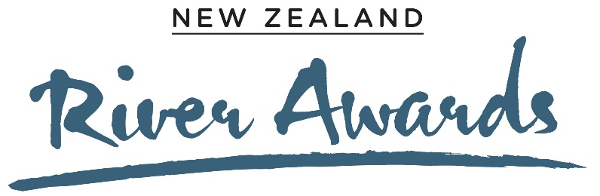

Catchment with Most Progress Toward River Health
Entry Form

This award was previously called the ‘Most Improved River Award’. The judging criteria have been expanded to consider catchment-wide actions and effort by people on the land and data-based evidence of changes in freshwater health. In 2021, this award will be open for entries for the first time.
The award will be based on actions and improvement for the period 2010-2020.
The word count reflects the weighting for judging of section 2 (30%), section 3 (40%) and section 4 (30%).
Supporting photos, data and diagrams are encouraged, and will not contribute to word count.
Please email this form to comms@cawthron.org.nz, or alternatively you can enter online at www.cawthron.org.nz/new-zealand-river-awards-entries. If you want to submit via email, the file size of supporting attachments will be limited, so you might like to use WeTransfer (an online, free file sharing platform) if your files are bigger than 2MB.
The deadline for entries is 31 July 2021. Judges may seek additional information during August and September to support entries. Finalists will be notified in October. Travel and accommodation expenses will be paid for up to two representatives of each finalist to attend the Awards ceremony in Wellington.

- Background and information (max. 300 words)
Describe your catchment, including:
- Biophysical features e.g. size, river flow/extent of surface water, physical structure, habitat, biology.
- Social – e.g. population, land use, recreational use, tangata whenua connections.
Click or tap here to enter text.

- Catchment values and objectives (max. 450 words)
Describe the goals of your initiative to improve river health and how actions are aligned with values and objectives of iwi, community and policy direction.
You may wish to cover the following points:
- What are the values of the catchment that you are trying to protect/restore?
- What priorities are you focusing on in the short and long term and what objectives are you aiming to achieve?
Tell us about the origin of the catchment project, longevity, stakeholder engagement and evolution of partnerships and collaboration, including how priorities were agreed upon.
Share with us your concept of Te Mana o te Wai and how you are giving effect to its principles.
Click or tap here to enter text.

- Actions and collaboration to improve river health (max. 600 words)
Describe how landowners, community organisations, businesses, individuals, local Iwi and Council are protecting/restoring the catchment and implementing the catchment plan.
You may wish to cover the following points:
- What are you doing to bring change/improvement and achieve your objectives? e.g. farm plans, wastewater treatment, wetland protection, riparian planting, chemical or irrigation management, stock management, fish passage enhancement.
- Who is involved in leading and implementing actions and monitoring?
- What groups and organisations are involved?
- What innovations can you share e.g. new approaches to land and freshwater management, use of technology, improved water security, understanding and including mātauranga Māori.
- Describe how you are monitoring progress towards your goals e.g. what locations within the catchment are being monitored, what’s being measured, who’s doing the measuring and why is monitoring being done in this way?
- Share with us your plans and actions for Te Mana o te Wai.
Click or tap here to enter text.

- Evidence of change and outcomes (max 450 words)
Provide evidence including trends, analysis and discussion of data that demonstrates an improvement in catchment health relating to your plans and actions.
You may wish to cover the following points:
- Evidence that illustrates change in land use, and implementation of land actions, or in-stream mitigations.
- Evidence that illustrates change in catchment health via water quality, water quantity, physical habitat, aquatic life or ecological processes e.g. what is the current state and trend at relevant LAWA monitoring sites?
- Additional evidence of giving effect to, or progress towards, Te Mana o te Wai.
Click or tap here to enter text.

- Contact details
Name of group entering
Click or tap here to enter text.
Name of catchment
Click or tap here to enter text.
Contact email for group entering
Click or tap here to enter text.
Contact number for group entering
Click or tap here to enter text.
Name & contact details of person making entry if different to above
Click or tap here to enter text.

