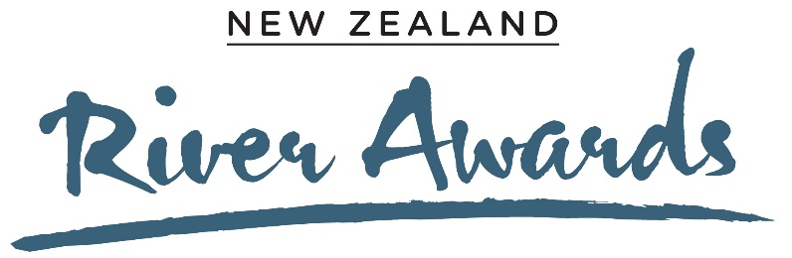

River Story Award

Entry form
This award is for compelling tales of individuals and/or communities working to improve freshwater health.
This award is judged by Gerard Hutching, a journalist and writer who specialises in environmental story-telling, and Dr Jane Kitson, an ecologist and environmental scientist with a background in traditional ecological research and Mātauranga Māori.
Please email this form to comms@cawthron.org.nz, or alternatively you can make a submission online at www.cawthron.org.nz/new-zealand-river-awards-submissions. Supporting photos, data and diagrams are encouraged, and will not contribute to word count.
The deadline for submissions is Thursday 8 July, 2021. After this date, the organisers may get in touch with you to get further information about your project. We are taking this approach so that you don’t to have to spend a long time putting together an entry – instead, we want ‘leads’ to the work being done.
Finalists will be notified in August and will be invited to participate in the production of communications, including a short video, between August and November 2021 to support the the sharing of their river stories. Travel and accommodation expenses will be paid for up to two representatives for each of the three finalist stories to attend the Awards ceremony in Wellington in November.

- Tell us your River Story (max. 500 words)
Click or tap here to enter text.

- Contact details
Name of individual or group entering
Click or tap here to enter text.
Name of river or catchment
Click or tap here to enter text.
Contact details (email or phone number)
Click or tap here to enter text.

Criteria:
Relevance
- What actions were undertaken to improve river health?
- How have the actions that make up the project contributed to improved river health?
- Has the project had, or is likely to have, a significant influence on land and water management practices?
- Does the environmental achievement have wide application?
- How have iwi hapu groups been involved in the project?
- Has Mātauranga Māori played a role in this project?
The Story
- The story should be new or not widely recognised
- The public are likely to find it inspiring
Objectives
- Does the story/project have clear and significant objectives?
- Has the environmental impact objective changed over time and, if so, in what way?
- What are the biggest challenges to achieving the objective?
Results
- What differences in river health parameters have been recorded over time?
- Are environmental outcomes regularly monitored? How is progress measured?
- Has the environmental objective been achieved or exceeded - has there been significant progress?
- Has or will the story/project result in intergenerational change?
- How has the project strengthened community connections with the awa and each other?

Credibility
- Is the story well-founded – is there sound financial, physical, scientific evidence to confirm the outcomes and make them readily applicable?
- Does the activity illustrate a new approach that could make a significant contribution to freshwater management?

